Notes written during work on my Math 501 project and paper on cancer accuracy using PCA
By Nasser Abbasi

This is my scratch notes files where I kept notes during work on the math 501 project (Spring 2007, CSUF)

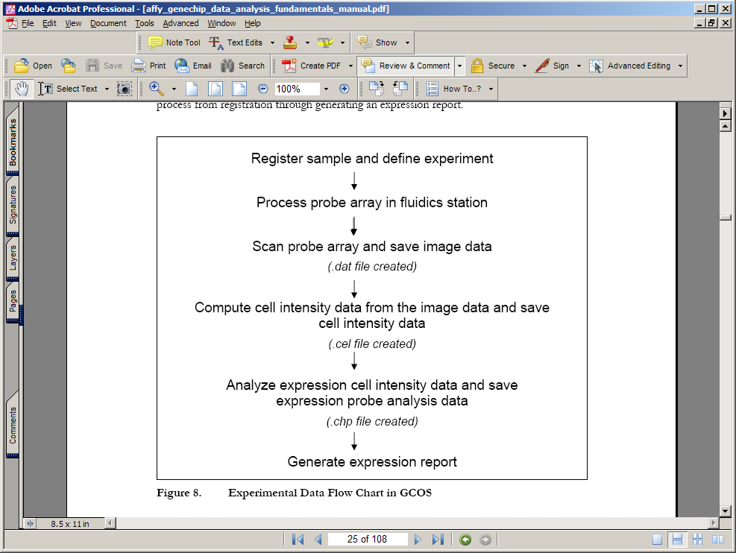
Geneship, it looks like I need a .chp file

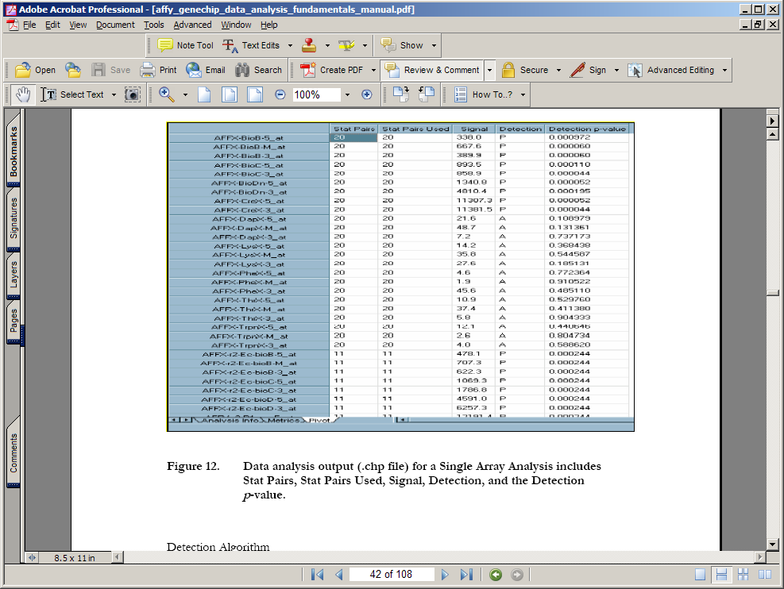

http://www.affymetrix.com/products/fos/cancer.affx see this for links to paper dealing with using affy geneships for cancer studies

idea: use ICA for : "identifying new cancer classes (class discovery) or for assigning tumors to known classes (class prediction)."

-------
Check this sometimes:

PCA disjoint models for multiclass cancer analysis using gene expression data
Bicciato S,
Luchini A,
Di Bello C.
Department of Chemical Process Engineering, University of Padova, via Marzolo, 9, 35131, Padova, Italy. silvio.bicciato@unipd.it
---------

http://www.affymetrix.com/support/technical/manual/expression_manual.affx
affy technical manauls.
--------

Standard Data Formats
Axon Instruments' GAL and GPR file formats are standards in the microarray industry.

GenePix Array List (GAL) Files
Easily construct lists describing the position and content of each spot on an array from plain text files. Substance name and ID lists can be pasted directly into the array settings file to create a GenePix Array List (GAL) file. GAL files can also be created from a collection of microwell plate files using the GenePix Array List Generator. Add as many columns as you like to the GAL file to track any sample information along with GenePix results. See the GenePix File Formats page for instructions.

File Formats
- Full support for 16-bit grayscale TIFF images.
- Results (GPR) file containing substance names, feature locations and all extracted data saved in ASCII file format for easy import into advanced analysis packages.
- Export Results in MAGE-ML format.
- Array List (GAL) files allow user-defined columns.

http://www.moleculardevices.com/pages/software/gn_genepix_pro.html
contains microarray data

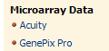

http://www.moleculardevices.com/pages/software/gn_acuity.html

to download microarray data files
http://cebs.niehs.nih.gov/cebs-browser/help/microarray/help-datafile_download.html

nih microarray
http://dir.niehs.nih.gov/microarray/
it looks like data is agilent data or affymetrix data.

This site talks about microarray data download
http://www.arabidopsis.org/help/tutorials/micro7.jsp

TAIR includes data using both cDNA arrays and Affymetrix GeneChips technology.

How to download and view MA data
http://www.arabidopsis.org/help/tutorials/micro7.jsp

DATA
ftp://ftp.arabidopsis.org/home/tair/Microarrays/

microarray analysis
http://www.statsci.org/micrarra/

databases for microarray
- Y. F. Leung's comparison of database systems
- BASE. BioArray Software Environment.
- BASE Plug-in for limma package created by Oja Spjuth, Uppsala University.
- GeneX. Open source database repository of gene expression data.
- Iobion Informatics. Produce GeneTraffic server based system.
http://chip.dfci.harvard.edu/stats/data.php#download describes the files used by genechip afymax

Chip File (.CHP)
The .CHP file contains Signal values and Presence Calls for each probe set on the microarray and can be viewed using MAS 5.0. The Statistical Algorithm is used to calculate the Signal values and Presence Calls from the probe-level fluorescence intensities contained in the .CEL file.

Cell Intensity File (.CEL)
The .CEL file contains fluorescence intensities for each probe on the microarray. When the .CEL file is opened in either MAS 5.0 or dChip, these probe-specific intensity values are used to reconstruct the scanned image of the hybridized array. It is recommended that the investigator view the .CEL images for each sample to make sure there are no obvious chip defects. For information on how the values in the .CEL file are calculated from the original scan, see the Affymetrix� MAS 5.0 Probe-level Analysis section of this website.
The probe-specific intensities in the .CEL file are also used in the Statistical Algorithm to calculate the probe-set-level Signals and Presence Calls recorded in the .CHP file. For information on how the intensity values in the .CEL file are used to calculate the .CHP file information, see the Presence Calls and Expression Estimates sections of this website.
http://www.affymetrix.com/products/software/specific/mas.affx affymetric website

http://www.gene-chips.com/GeneChips.html#Datamining places to find data

http://nciarray.nci.nih.gov/ center of cancer research
http://nciarray.nci.nih.gov/cgi-bin/gipo to get data from above

K Kudoh, M Ramanna, R Ravatn, AG Elkahloun, ML Bittner, PS Meltzer, JM Trent, WS Dalton, KV Chin, Monitoring the expression profiles of doxorubicin-induced and doxorubicin-resistant cancer cells by cDNA microarray, Cancer Research 60: 15 (AUG 1 2000) Pages 4161-4166

http://discover.nci.nih.gov/ cancer and microarray
http://discover.nci.nih.gov/datasets.jsp has cancer data?

http://discover.nci.nih.gov/cellminer/loadDownload.do contains download of .cel files (cancor data)

http://www.molbiolcell.org/cgi/content/full/13/6/1929 link to chen paper, where earlier paper by Dr Lee references and used data from.

http://www.ncbi.nlm.nih.gov/projects/geo/ gene expression database query

http://smd-www.stanford.edu/ standford microarray DB

http://genome-www.stanford.edu/hcc/Figures/ArrayInformation.htm array for chen paper

http://genome-www.stanford.edu/hcc/ chen site liver cancer gene expression
 | No. of Cases | Category | Subcategory
Adenoma | 3 | Adenoma | Liver
FNH | 4 | FNH | Liver
HCC | 102 | Primary tumors | Liver
Non-tumor liver | 74 | non-tumor tissues | Liver
Liver cancer cell lines | 10 | Cell-line | Liver
http://smd.stanford.edu/cgi-bin/data/viewDetails.pl?fullID=10029GENEPIX0 chen liver data here.
http://www.bio.davidson.edu/projects/GCAT/SMDdirections.html directions on finding GCAT Data on the Stanford Microarray Database
microarray databases
http://smd-www.stanford.edu/resources/databases.shtml
how to download chen data
go to http://smd.stanford.edu/cgi-bin/search/QuerySetup.pl and select expierementer as XINCHEN
K>> size(BladderData)
6688 126
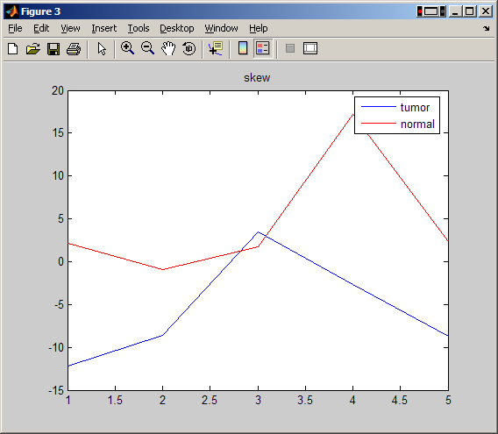
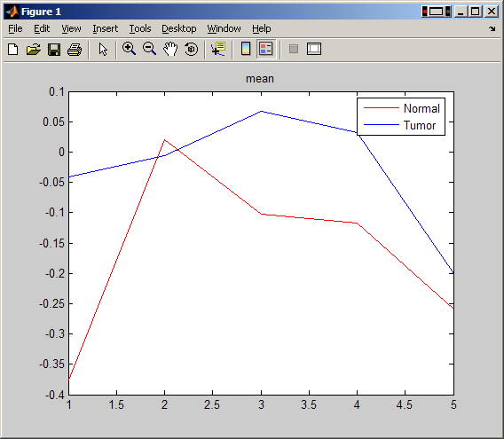

http://www.molbiolcell.org/cgi/content/full/14/8/3208 chen second paper
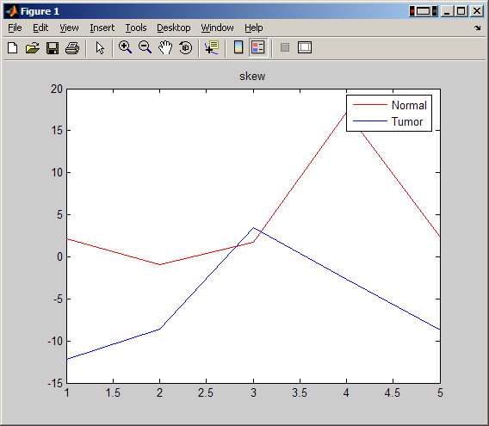
Links from Dr Lee:

http://jnci.oxfordjournals.org/cgi/content/full/94/17/1320#SEC1

http://www.pnas.org/cgi/content/abstract/101/25/9309?view=abstract
We collected and analyzed 40 published cancer microarray data sets, comprising 38 million gene expression measurements from >3,700 cancer samples.

40 data sets were publicly available and compiled; in total, 37,901,459 gene measurements from 3,762 microarray experiments. Most data sets were of two general formats, either single-channel intensity data, usually corresponding to Affymetrix microarrays, or dual-channel ratio data, usually corresponding to spotted cDNA microarrays, and in the majority of cases, a single composite data file was provided by the study authors and incorporated into our database.

What does this mean?
Fig. 3. Meta-signature of undifferentiated cancer. Sixty-nine genes that are overexpressed in undifferentiated cancer relative to well differentiated cancer (Q < 0.10) in at least four of seven signatures representing six types of cancer. See Fig. 2 legend for description.

http://www.pnas.org/content/vol101/issue25/images/large/zpq0240451350003.jpeg

cancer profiling database:
http://www.oncomine.org/main/index.jsp ====> this one

I logged into the above, here is some data I downloaded

Bladder cancer

Title: Gene expression in the urinary bladder: a common carcinoma in situ gene expressionsignature exists disregarding histopathological classification. Organization: Department of Clinical Biochemistry, Aarhus University Hospital, Skejby, AarhusN, Denmark. Reference: Cancer Res 2004/06/02 Tissue: Bladder Array Type: Affymetrix, Human Genome U133A Array Study Description: Sample Description: Normal Bladder - Biopsy (9), Normal Bladder Mucosa - Cystectomy (5), Carcinoma In Situ (4), NA (2), Superficial Transitional Cell Carcinoma (27), Invasive Transitional Cell Carcinoma (13)
Data Link: http://www.mdl.dk/Files/supplementary%20information%20-%20CIS.pdf
http://www.ncbi.nlm.nih.gov/projects/geo/gds/gds_browse.cgi?gds=1479
http://www.ncbi.nlm.nih.gov/projects/geo/query/acc.cgi?acc=GSE3167

Dr Chen Xin send me this:
Hi Nasser:
You should be able to find the arrays at:
http://smd.stanford.edu/cgi-bin/publication/viewPublication.pl?pub_no=107
Also at GEO:
http://www.ncbi.nlm.nih.gov/projects/geo/query/acc.cgi?acc=GSE3500
Good luck with your research!
Best,
Xin

Here it is in GEO also:

http://www.ncbi.nlm.nih.gov/entrez/query.fcgi?db=gds&term=GSE3500[Accession]&cmd=search
here it below in GEO (above), I think I only need the liver one
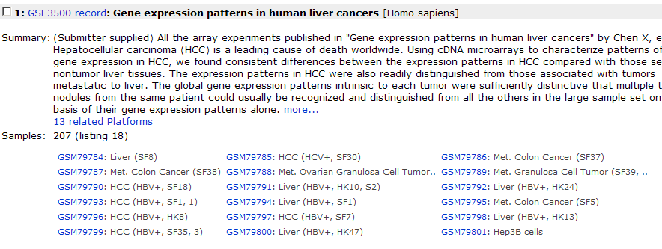
Sample GSM79784 Simple annotation: Non-tumor tissue, Liver

This is meta data description of data published in Chen paper Liver cancer 2002.

<publication>
!Citation=Chen et al. MBC in Press, published April 3, 2002 as 10.1091/mbc.02-02-0023
!Title=Gene expression patterns in human liver cancers
!PubMedID=
<experiment_set>
!Name=HCCpaper_All_arrays
!ExptSetNo=1162
!Description=All the array experiments published in "Gene expression patterns in human liver cancers" by Chen X, et al.
</experiment_set>
<experiment_set>
!Name=HCCpaper_Figure1_arrays
!ExptSetNo=1164
!Description=Experiments used in Figure one of the HCC paper by Chen X, et al.
</experiment_set>
<experiment_set>
!Name=HCCpaper_Figure3_arrays
!ExptSetNo=1165
!Description=Experiments used in Figure 3 of the HCC paper by Chen X, et al.
</experiment_set>
<experiment_set>
!Name=HCCpaper_Figure6_arrays
!ExptSetNo=1166
!Description=Experiments used in the Figure 6 of HCC paper by Chen X, et al
</experiment_set>
</publication>

To read SOFT files
http://www2.warwick.ac.uk/fac/sci/moac/currentstudents/peter_cock/r/geo/

soft file format description
http://www.ncbi.nlm.nih.gov/projects/geo/info/soft2.html#SOFTformat

Sample data table headers and content
The first row in the file must be a header line that identifies the content of each column. The two required columns are listed below. In addition to the required columns, submitters are encouraged to supply any number of auxiliary non-standard columns describing, for example, supporting measurements and calculations, quality evaluations or flags. Columns may appear in any order after the ID_REF column. In this way, GEO is a flexible and open system, allowing you to provide all information necessary to thoroughly describe your hybridization results.
- ID_REF: (Required) Identifier reference - these should match the unique identifiers given in the identifier (ID) column of the corresponding Platform data table.
- VALUE: (Required) These values should be the final, normalized quantification measurements that are comparable across rows and Samples, and preferably processed as described in any accompanying manuscript. Values that should be discarded (e.g., background higher than count, or otherwise flagged as 'bad') should either be left blank or labeled as "null".
  - For single channel data, this column should contain normalized (scaled) signal count data.
  - For dual channel data, this column should contain normalized log ratio data (preferably test/reference).
Matlab bioinformatics toolbox
http://www.mathworks.com/access/helpdesk_r13/help/toolbox/bioinfo/a1052335616.html

http://www.ncbi.nlm.nih.gov/About/primer/microarrays.html

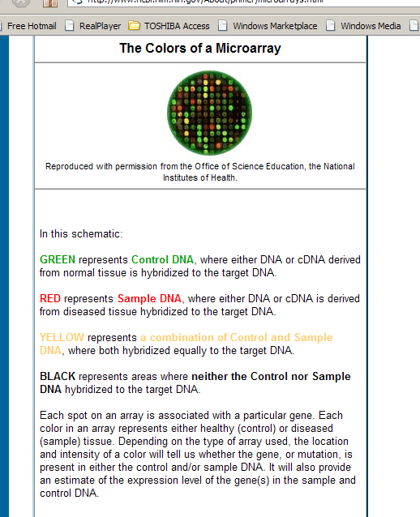

Some learning :

http://learn.genetics.utah.edu/units/basics/tour/

soft file:
!Sample_series_id = GSE3500
!Sample_data_row_count = 24192
#ID_REF = ID_REF

#CH1I_MEAN = Mean feature pixel intensity at wavelength 532 nm.; Type: integer; Scale: linear_scale

#CH2I_MEAN = Mean feature pixel intensity at wavelength 635 nm.; Type: integer; Scale: linear_scale

#CH1B_MEDIAN = The median feature background intensity at wavelength 532 nm.; Type: integer; Scale: linear_scale; Channel: Cy3 Channel; Background

#CH2B_MEDIAN = The median feature background intensity at wavelength 635 nm.; Type: integer; Scale: linear_scale; Channel: Cy5 channel; Background

#CH1D_MEAN = The mean feature pixel intensity at wavelength 532 nm with the median background subtracted.; Type: integer; Scale: linear_scale; Channel: Cy3 Channel

#CH2D_MEAN = .The mean feature pixel intensity at wavelength 635 nm with the median background subtracted.; Type: integer; Scale: linear_scale; Channel: Cy5 channel

#CH1I_MEDIAN = Median feature pixel intensity at wavelength 532 nm.; Type: integer; Scale: linear_scale

#CH2I_MEDIAN = Median feature pixel intensity at wavelength 635 nm.; Type: integer; Scale: linear_scale

#CH1B_MEAN = The mean feature background intensity at wavelength 532 nm.; Type: integer; Scale: linear_scale; Background

#CH2B_MEAN = The mean feature background intensity at wavelength 635 nm.; Type: integer; Scale: linear_scale; Background

#CH1D_MEDIAN = The median feature pixel intensity at wavelength 532 nm with the median background subtracted.; Type: integer; Scale: linear_scale

#CH2D_MEDIAN = The median feature pixel intensity at wavelength 635 nm with the median background subtracted.; Type: integer; Scale: linear_scale

#CH1_PER_SAT = The percentage of feature pixels at wavelength 532 nm that are saturated.; Type: integer; Scale: linear_scale

#CH2_PER_SAT = The percentage of feature pixels at wavelength 635 nm that are saturated.; Type: integer; Scale: linear_scale

#CH1I_SD = The standard deviation of the feature intensity at wavelength 532 nm.; Type: integer; Scale: linear_scale; Channel: Cy3 Channel

#CH2I_SD = The standard deviation of the feature pixel intensity at wavelength 635 nm.; Type: integer; Scale: linear_scale; Channel: Cy5 channel

#CH1B_SD = The standard deviation of the feature background intensity at wavelength 532 nm.; Type: float; Scale: linear_scale; Channel: Cy3 Channel; Background

#CH2B_SD = The standard deviation of the feature background intensity at wavelength 635 nm.; Type: integer; Scale: linear_scale; Channel: Cy5 channel; Background

#PERGTBCH1I_1SD = The percentage of feature pixels with intensities more than one standard deviation above the background pixel intensity, at wavelength 532 nm.; Type: integer; Scale: linear_scale

#PERGTBCH2I_1SD = The percentage of feature pixels with intensities more than one standard deviation above the background pixel intensity, at wavelength 635 nm.; Type: integer; Scale: linear_scale

#PERGTBCH1I_2SD = The percentage of feature pixels with intensities more than two standard deviations above the background pixel intensity, at wavelength 532 nm.; Type: integer; Scale: linear_scale

#PERGTBCH2I_2SD = The percentage of feature pixels with intensities more than two standard deviations above the background pixel intensity, at wavelength 532 nm.; Type: integer; Scale: linear_scale

#SUM_MEAN = The sum of the arithmetic mean intensities for each wavelength, with the median background subtracted.; Type: integer; Scale: linear_scale

#SUM_MEDIAN = The sum of the median intensities for each wavelength, with the median background subtracted.; Type: integer; Scale: linear_scale

#RAT1_MEAN = Ratio of the arithmetic mean intensities of each spot for each wavelength, with the median background subtracted. Channel 1/Channel 2 ratio, (CH1I_MEAN - CH1B_MEDIAN)/(CH2I_MEAN - CH2B_MEDIAN) or Green/Red ratio.; Type: float; Scale: linear_scale

#RAT2_MEAN = The ratio of the arithmetic mean intensities of each feature for each wavelength, with the median background subtracted.; Type: float; Scale: linear_scale

#RAT2_MEDIAN = The ratio of the median intensities of each feature for each wavelength, with the median background subtracted.; Type: float; Scale: linear_scale

#PIX_RAT2_MEAN = The geometric mean of the pixel-by-pixel ratios of pixel intensities, with the median background subtracted.; Type: float; Scale: linear_scale

#PIX_RAT2_MEDIAN = The median of pixel-by-pixel ratios of pixel intensities, with the median background subtracted.; Type: float; Scale: linear_scale

#RAT2_SD = The geometric standard deviation of the pixel intensity ratios.; Type: float; Scale: linear_scale

#TOT_SPIX = The total number of feature pixels.; Type: integer; Scale: linear_scale

#TOT_BPIX = The total number of background pixels.; Type: integer; Scale: linear_scale

#REGR = The regression ratio of every pixel in a 2-feature-diameter circle around the center of the feature.; Type: float; Scale: linear_scale

#CORR = The correlation between channel1 (Cy3) & Channel 2 (Cy5) pixels within the spot, and is a useful quality control parameter. Generally, high values imply better fit & good spot quality.; Type: float; Scale: linear_scale

#DIAMETER = The diameter in um of the feature-indicator.; Type: integer; Scale: linear_scale

#X_COORD = X-coordinate of the center of the spot-indicator associated with the spot, where (0,0) is the top left of the image.; Type: integer; Scale: linear_scale

#Y_COORD = Y-coordinate of the center of the spot-indicator associated with the spot, where (0,0) is the top left of the image.; Type: integer; Scale: linear_scale

#TOP = Box top: int(((centerX - radius) - Xoffset) / pixelSize).; Type: integer; Scale: linear_scale

#BOT = Box bottom: int(((centerX + radius) - Xoffset) / pixelSize).; Type: integer; Scale: linear_scale

#LEFT = Box left: int(((centerY - radius) - yoffset) / pixelSize).; Type: integer; Scale: linear_scale

#RIGHT = Box right: int(((centerY + radius) - yoffset) / pixelSize); Type: integer; Scale: linear_scale

#FLAG = The type of flag associated with a feature: -100 = user-flagged null spot; -50 = software-flagged null spot; 0 = spot valid.; Type: integer; Scale: linear_scale

#CH2IN_MEAN = Normalized value of mean Channel 2 (usually 635 nm) intensity (CH2I_MEAN/Normalization factor).; Type: integer; Scale: linear_scale; Channel: Cy5 channel

#CH2BN_MEDIAN = Normalized value of median Channel 2 (usually 635 nm) background (CH2B_MEDIAN/Normalization factor).; Type: integer; Scale: linear_scale; Channel: Cy5 channel; Background

#CH2DN_MEAN = Normalized value of mean Channel 2 (usually 635 nm) intensity with normalized background subtracted (CH2IN_MEAN - CH2BN_MEDIAN).; Type: integer; Scale: linear_scale; Channel: Cy5 channel

#RAT2N_MEAN = Type: float; Scale: linear_scale

#CH2IN_MEDIAN = Normalized value of median Channel 2 (usually 635 nm) intensity (CH2I_MEDIAN/Normalization factor).; Type: integer; Scale: linear_scale

#CH2DN_MEDIAN = Normalized value of median Channel 2 (usually 635 nm) intensity with normalized background subtracted (CH2IN_MEDIAN - CH2BN_MEDIAN).; Type: integer; Scale: linear_scale

#RAT1N_MEAN = Ratio of the means of Channel 1 (usually 532 nm) intensity to normalized Channel 2 (usually 635 nm) intensity with median background subtracted (CH1D_MEAN/CH2DN_MEAN). Channel 1/Channel 2 ratio normalized or Green/Red ratio normalized.; Type: float; Scale: linear_scale

#RAT2N_MEDIAN = Channel 2/Channel 1 ratio normalized, RAT2_MEDIAN/Normalization factor or Red/Green median ratio normalized.; Type: float; Scale: linear_scale

#VALUE = Log (base 2) of the ratio of the mean of Channel 2 (usually 635 nm) to Channel 1 (usually 532 nm) [log (base 2) (RAT2N_MEAN)].; Type: float; Scale: log_base_2

#LOG_RAT2N_MEDIAN = Log (base 2) of the ratio of the median of Channel 2 (usually 635 nm) to Channel 1 (usually 532 nm) [log (base 2) (RAT2N_MEDIAN)].; Type: float; Scale: log_base_2
!sample_table_begin

The Gene Expression Omnibus (GEO) repository at the National Center for Biotechnology Information (NCBI) archives and freely disseminates microarray and other forms of high-throughput data generated by the scientific community.
http://nar.oxfordjournals.org/cgi/content/full/gkl887?ijkey=ysG9Li2nfUYJvdZ&keytype=ref

chen data for liver, 2002 paper:
http://www.ncbi.nlm.nih.gov/projects/geo/query/acc.cgi?acc=GSM79784

control is on channel 1, tumor on channel 2.
Platform ID GPL3009 Series (1)
GSE3500 | Gene expression patterns in human liver cancers

Software format descriptions. Also shows relationship between platform/samples/series
http://www.ncbi.nlm.nih.gov/projects/geo/info/soft2.html#SOFTformat

The distinctive gene expression patterns are characteristic of the tumors and not the patient
~1640 genes that are differentially expression in HCC and non-tumor liver
Top 600 genes that are differentially expressed in HCC and Non-tumor Liver

Microarray procedure
23075 cDNA clones, representing about 17,400 genes, were mechanically printed onto
treated glass microscope slides

EDU>> getgeodata('GSM79795','ToFile','GSM79795.txt');
EDU>> GEOSOFTData = geosoftread('GSM79795.txt');

GEO Platform (GPL)
These files describe a particular type of microarray. They are annotation files.
GEO Sample (GSM)
Files that contain all the data from the use of a single chip. For each gene there will be multiple scores including the main one, held in the VALUE column.
GEO Series (GSE)
Lists of GSM files that together form a single experiment.
GEO Dataset (GDS)
These are curated files that hold a summarised combination of a GSE file and its GSM files. They contain the expression level for each gene from each sample (i.e. just the VALUE field from the GSM file).

Format for the PLATFORM file. It looks I might need access to this also to know which gene goes with which spot
#ID =
#METACOLUMN =
#METAROW =
#COLUMN =
#ROW =
#SPOT_ID =
#CONTROL =
#SEQUENCE DESCRIPTION =
#POLYMER =
#TYPE =
#GenBank =

Describes formats

http://www.ncbi.nlm.nih.gov/projects/geo/info/overview.html

platform record

Data table header descriptions
ID | Affymetrix Probe Set ID
Species Scientific Name | The genus and species of the organism represented by the probe set.
Annotation Date | The date that the annotations for this probe array were last updated. It will generally be earlier than the date when the annotations were posted on the Affymetrix web site.
GB_LIST | GenBank Accession Number
SPOT_ID | Sequence Type: Indicates whether the sequence is an Exemplar, Consensus or Control sequence. An Exemplar is a single nucleotide sequence taken directly from a public database. This sequence could be an mRNA or EST. A Consensus sequence, is a nucleotide sequence assembled by Affymetrix, based on one or more sequence taken from a public database.
Sequence Source | The database from which the sequence used to design this probe set was taken.
Representative Public ID | The accession number of a representative sequence. Note that for consensus-based probe sets, the representative sequence is only one of several sequences (sequence sub-clusters) used to build the consensus sequence and it is not directly used to derive the probe sequences. The representative sequence is chosen during array design as a sequence that is best associated with the transcribed region being interrogated by the probe set. Refer to the "Sequence Source" field to determine the database used.
Gene Title | Title of Gene represented by the probe set.
Gene Symbol | A gene symbol, when one is available (from UniGene).
Entrez Gene | Entrez Gene database UID
RefSeq Transcript ID | References to multiple sequences in RefSeq. The field contains the ID and Description for each entry, and there can be multiple entries per ProbeSet.
RGD Name | Rat Genome Database
Gene Ontology Biological Process | Gene Ontology Consortium Biological Process derived from LocusLink. Each annotation consists of three parts: "Accession Number // Description // Evidence". The description corresponds directly to the GO ID. The evidence can be "direct", or "extended".
Gene Ontology Cellular Component | Gene Ontology Consortium Cellular Component derived from LocusLink. Each annotation consists of three parts: "Accession Number // Description // Evidence". The description corresponds directly to the GO ID. The evidence can be "direct", or "extended".
Gene Ontology Molecular Function | Gene Ontology Consortium Molecular Function derived from LocusLink. Each annotation consists of three parts: "Accession Number // Description // Evidence". The description corresponds directly to the GO ID. The evidence can be "direct", or "extended".

Fields in PLATFORM record

ID MetaRow Number of metarow in the metagrid where the spot is located
MetaColumn Number of metacolumn in the metagrid where the spot is located
Row Number of row in the subgrid where the spot is located
Column Number of column in the subgrid where the spot is located
Array ID Array identifier
Accession Accession of TIGR Gene Indices contig or GenBank number
GB_ACC GenBank accession
SPOT_ID SPOT ID Spot identifier
Description Gene description based on current top blast hit
SEQUENCE Sequence

Look for: AA225741,AA259201,AI732153,AI820965

Platform GPL2831
9 1 1 9 1 IMAGE:1008379 DNA cDNA_clone

Platform GPL2938 (44,500 rows)
33301 4 9 21 26 IMAGE:1008379 DNA cDNA_clone

PLATFORM = GPL3007
705 1 1 5 26 IMAGE:1008379 DNA cDNA_clone

PLATFORM = GPL3009
585 1 1 25 21 IMAGE:1008379 DNA cDNA_clone

The following Platforms that has AA225741,AA259201,AI732153,AI820965 on location

729 1 1 1 27

GPL2648,GPL2649, GPL2868, GPL2906, GPL2935, GPL2948 , GPL3008, GPL3010,GPL3011

Look at spot ID:
1491 2 1 7 27 IMAGE:1286706 DNA cDNA_clone AA740767
735 1 1 7 27 IMAGE:1286706 DNA cDNA_clone AA740767
711 1 1 11 26 IMAGE:1286706 DNA cDNA_clone AA740767

http://smd.stanford.edu/cgi-bin/data/viewData.pl?fullID=12416GENEPIX0
use SMD, not GEO.
SMD allows better control on what fields to download

To see effective of filtering on data, go to
http://smd.stanford.edu/cgi-bin/data/grids.pl?fullID=12406GENEPIX0 and select different filters.

24,192 is the total number of spots on the microarray. However, not all spots can be loaded with genes, some can be empty. Hence the number of genes does not neccessirally the same as number of spots.

SMD scheme !

https://genome.unc.edu/cgi-bin/SMD/tableSpecifications?table=RESULT

SECTOR spot sector grid coordinate
SECTORROW spot row grid coordinate
SECTORCOL spot column grid coordinate

From http://www.microarray.org/sfgf/common/misc/faq.jsp

• How are the features(spots) arranged on the SFGF microarray?
The current MM array edition contains 48 sectors of 30 rows and 30 columns of spots in each sector, printed at 146 micron spacing. The recent SH arrays have been printed with 30 columns per sector and with 29 or 30 rows in each of the 48 sectors. The spot diameter is 80 - 90 microns. For details about your particular array batch, please refer to the QC notes page of the website(you must have an SFGF account and be logged in to access the QC notes page).
The total possible number of spots that we can fit into this configuration is 43,200, and there is one array per slide.
If one orients the array with the barcode at the bottom, the sectors are numbered with #1 in the upper left-hand corner, 2-4 proceeding to the right, 5-8 in the second row of sectors, and so on.

Sector numbering for my project

1 2 3 4
5 6 7 8
9 10 11 12
13 14 15 16
17 18 19 20
21 22 23 24
25 26 27 28
29 30 31 32

